**A PROPOSED OFFERING OF ENHANCING BARANGGAY SERVICES IN NBBS PROPER: THE DEVELOPMENT OF A REQUEST SYSTEM VALENZUELA BRANCH**

A Project Proposal Presented to the Faculty of Datamex College of Saint Adeline, Inc.

In Partial Fulfillment of the Requirements for the

Degree of Bachelor of Science in Information Technology

## By:

Tingson, Emerald Maja

Espinosa, Angelica

Pore, Kim

Canada, Jesse Ver

**August 2025**

**PROJECT PROPOSAL**

## INTRODUCTION

Barangays are the smallest units of government in the Philippines, but they carry big responsibilities when it comes to serving the people. They handle important services like issuing certificates, barangay clearances, and permits, as well as assisting residents with their everyday needs. In NBBS Proper, Navotas, most of these services are still done manually using paper records. This often leads, typo or misspelled of information, misplaced documents, and difficulties in tracking requests. Because of this, residents experience inconvenience, and barangay staff struggle to keep everything organized.

In today’s modern world, technology is a powerful tool that can make government services faster, easier, and more transparent. For this reason, the project titled “Enhancing Barangay Services in NBBS Proper: The Development of an Online Request System” was created. This system is designed to help residents submit and track their requests online, anytime and anywhere with an internet connection. Instead of, residents can simply log in, send their request, and monitor its progress without leaving their homes. The online request system is simple but effective. Residents can register, create an account, and submit requests for documents like permits or certificates. Barangay staff can process these requests, update their status, and approve or reject them. At the same time, the barangay captain can monitor the overall activities and generate reports to make better decisions.

The system also keeps records safe and organized, reducing errors and making sure no request gets lost. By moving the barangay request process online, this project aims to bring faster and more efficient services to the community. It will lessen paperwork, minimize mistakes, and promote transparency by allowing residents to see the real-time status of their requests. In this way, the barangay can better serve its people, and residents can enjoy a smoother and more convenient experience.

## CLIENT INFORMATION

Barangay NBBS Proper in Navotas City is one of the most populated communities in the area. With many residents depending on the barangay for services such as certificates, permits, and other documents, the demand for assistance is high. At present, most of these services are still done manually, which often causes of misspelled and wrong information, and difficulty in keeping records organized.

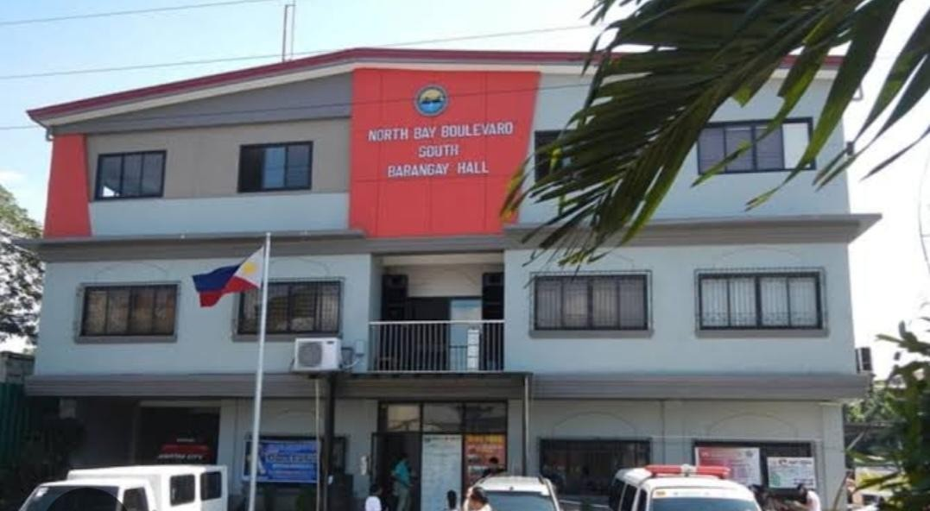

*Image 1. “Barangay Nbbs proper Navotas”*

Client Organization: Barangay NBBS Proper, Navotas City Contact Details:

Barangay Captain: Hon. Elvis Illut Desabille Email: [barangay123@gmail.com](mailto:barangay123@gmail.com)

Phone: (02) 1234-5678

Address: Blk 10 Lot 1 Cattleya St., NBBS Proper, Navotas City

## PROJECT SCOPE

The project will create a secure web-based request system. This platform will let residents submit barangay document requests online while minimizing delays and errors with real-time tracking. Barangay staff will have dashboards to view, process, and track these requests, along with the ability to generate reports. Each role has specific access, giving residents, staff, and the barangay captain the tools they need. Staff will manage requests and updates, while the barangay captain will oversee reports and monitor the entire system. Built-in features will enable efficient tracking of request status, leading to an organized and user-friendly platform that improves barangay services and resident satisfaction.

## Expected Deliverables

* A functioning online request system available on desktop for submitting and processing barangay documents.
* An easy-to-use interface where residents can submit requests and staff can view and update them. A search function will help staff quickly locate requests by name, type, or date.
* Key features include request submission, status tracking, dashboard.
* A login system with different roles. Staff can manage requests and generate reports, while residents can submit requests and track their status. The barangay captain can oversee all activities and monitor reports.

## Expected Outcomes

* A faster and more organized process for resident requests compared to the current manual method.
* Less effort for both residents and staff since requests can be submitted and tracked online.
* It will be easier for staff and the barangay captain to access reports and history, helping them make better decisions.

## Residents will be more satisfied because they can submit requests at any time and monitor them effectively.

## Exclusions

* SMS or email notifications are not included.
* Online payment features are not included you can walk in to the barangay
* The system will not have a public website for viewing all requests.

## Assumptions

* Residents have internet access and basic computer skills to submit requests.
* Barangay staff will check and update requests regularly.
* Staff will enter accurate information and manage request status correctly.
* Residents can edit her personal information.

## Constraints

* Residents need internet access to use the system.
* Notifications and updates depend on barangay staff to correctly input information.
* The system requires functioning hardware and network availability at the barangay office.

## PROJECT APPROACH

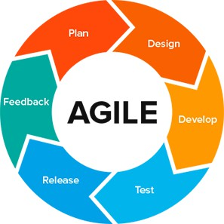

*Figure 1 : Agile Methodology*

This project uses Agile Methodology because it allows the system to be developed in small, manageable parts. This approach makes it easier to test features, get feedback from residents and barangay staff, and make improvements during development. Agile is flexible, user centered, and helps ensure the final system is efficient, practical, and meets the needs of both users and staff.

## Plan

The project will begin with planning, where the team will identify the needs of the barangay and list the main features of the request system, such as submitting requests, tracking status, and managing approvals.

## Design

After planning, the team will design the system by creating the user interface, database structure, and workflow of how residents and barangay staff will use the system.

## Develop

Once the design is ready, our team will develop the system by coding its main functions, such as request submission, status updates, account management, and report generation.

## Test

After development, the system will be tested to check for errors, confirm accuracy, and make sure all features work properly and are easy to use.

## Deploy

When testing is complete, the system will be deployed in the barangay. It will be introduced to staff and residents, with simple training provided to ensure proper use.

## Review

Finally, the team will review the system’s performance, gather feedback from barangay staff and residents, and make improvements for future updates.

## PROJECT TEAM

|  |  |  |
| --- | --- | --- |
|  | **ROLE** | **DESCRIPTION** |
|  | PROJECT LEADER | Responsible for assigning tasks to each member and monitoring system progress. She ensures deadlines are met and provides guidance throughout the project. |
|  | PROGRAMMER | Responsible for developing  the system and setting up the database. Knowledgeable in computer systems and  software development. |
|  | DATA GATHER/ SYSTEM DESIGNER | Designs the user interface to make the system intuitive, functional, and aesthetically pleasing for staff.  Responsible for collecting, compiling, and organizing information. |
|  | SYSTEM ANALYST/ DATA GATHERER | Guides the programmer, provides system workflow, and tests the system for bugs and errors.  Compiling information from various sources to support our research |

**PROJECT TIMELINE**

The estimated duration of our project is 1-16 weeks. Below is the timeline showing the major phases and deliverables:

|  |  |
| --- | --- |
| WEEKS | TASK AND ACTIVITY |
| Week 1 | Gathering, and understanding the title of our System, and initial planning. |
| Week 2 | Conducting research and gathering information on barangay services. |
| Week 3 | Analyze current barangay processes and identify problems. |
| Week 4 | Define system requirements and specifications. |
| Week 5 | Design system architecture, database structure, and interface mockups. |
| Week 6 | Set up development environment (XAMPP, PHP, MySQL) |
| Week 7 | Begin coding core features: user registration and login. |
| Week 8 | Develop a request submission module for residents. |
| Week 9 | Develop staff dashboard and request tracking features |
| Week 10 | Implement reporting functions and data management features. |
| Week 11 | Testing the system based on test results and fixing errors |

|  |  |
| --- | --- |
| Week 12 | . Final presentation, system deployment, and submission of Docu |

Table 1 : Project Timeline

**PROJECT RESOURCES**

**Hardware**

* Computer/Deskstop ( PC i3 526 GB 16 GB RAM)
* Printer(Epson or canon)

**Software**

* Designing:Canva/Figma
* Database:Xamp
* Microsoft office for documentation
* Visual Studio Code
* Google Chrome

**Human Resources**

* Programmer Designer
* System Analyst Tester
* Data Gatherer

## RISK MANAGEMENT

Managing potential risks is important for the smooth implementation of the Barangay Request System for NBBS Proper. These are the possible issues that we may face:

## 

## Technical Issues

One possible risk is facing technical problems, such as system bugs, server errors, or software not working properly. These issues can delay development or affect the system when it is in use. To avoid this, the team will do regular testing, use trusted tools (PHP, XAMPP, MySQL), and keep technical documentation updated so problems can be fixed quickly.

## Data Loss or Security Problems

Since the system will store important resident requests and barangay records, data loss or security breaches are a concern. Losing information or having it accessed by unauthorized people could affect barangay operations and resident trust. To reduce this risk, we will back up data regularly, use strong passwords, limit access to authorized staff only, and apply basic security measures.

## Delays in Development

Delays may happen if tasks take longer than expected or if unexpected issues arise. To handle this, we will follow a 16-week timeline with buffer time and check progress regularly to keep the project on track.

## User Acceptance Risk

Residents or barangay staff may find the system difficult to use or may resist adopting it. To reduce this risk, the system will have a simple interface, clear instructions, and guidance

will be provided during use. Feedback will be collected and used to improve usability.

## Operational Risk

The system may experience downtime or limited access due to internet or electricity problems at the barangay. To mitigate this, maintenance will be scheduled during low-usage hours, and backup procedures will be in place to ensure the system continues to operate effectively

## 

## PROJECT GOVERNANCE

The Project Manager will guide the whole development of the Request System for Barangay NBBS Proper. The Project Manager’s role is to lead the development team, assign tasks, check progress, and make sure that all work is completed on time. They will also ensure that the system is built according to the needs and requirements of Barangay NBBS Proper.

All major decisions about the project scope (what features and functions the system will include) and the timeline (how long each phase will take) will be decided in coordination between the Project Manager and the Barangay Officials. This collaboration ensures that both the development team and the barangay leadership are aligned in their goals, allowing the project to move forward smoothly.

By having clear governance, responsibilities are properly divided, accountability is established, and progress is closely monitored. This approach helps guarantee that the system will be finished successfully and will serve its purpose of enhancing barangay services.

## APPENDIX

**Local Literature and Studies**

Fortuito et al. (2016) conducted a study on enhancing public service delivery using the i* framework. Visualizing stakeholder relationships and workflows helped identify inefficiencies and improved decision-making in public service systems.

Mercurio and Hernandez (2022) developed an open data system for barangay-level planning and service delivery. Their system integrated data management to help local officials identify areas with high service demand.

Del Rosario, Reyes, and Baluyot (2021) introduced an offline community e-service system for common barangay transactions, highlighting how automation reduced queues, increased transparency, and improved resident satisfaction.

Soriano (2023) emphasized digitalization in LGUs to streamline services and promote transparency. Offline principles can be applied to barangay service request systems for better public service.